***Misr University of Science and Technology***

***College of Engineering and Technology***

***Department of Mechatronics Engineering***

**inverted pendulum on cart**

By:

|  |  |
| --- | --- |
| *NAME* | *ID* |
| 81087 | Abdelhamid Mohamed Ali Ibrahim |
| 91629 | Bishoy Makram Youssef Tawadrous |
| 86357 | Fahad Nazih Ahmed Mohamed Ali |
| 91615 | Youhana Morcos Elkes Hana |
| 95829 | Youssef Ahmed Hamed Abdeltwab |
| 91489 | David Maged Yousef |

Supervised By:

|  |  |
| --- | --- |
| *Dr. Bekhet Mohamed* | *Japanese University* |
| *Eng. Omar Ashraf* | *Lecture assistant* |

**inverted pendulum on cart**

**Definition**

An inverted pendulum consists of a mass (the pendulum) mounted on a pivot point. Mounted on a moving cart along a slider the pendulum is free to be in the gravitation direction The challenge is to keep the pendulum balanced in an inverted (upright) position, despite external disturbances.

**Introduction:**

The system in this example consists of an inverted pendulum mounted to a motorized cart. The inverted pendulum system is an example commonly found in control system textbooks and research literature. Its popularity derives in part from the fact that it is unstable without control, that is, the pendulum will simply fall over if the cart isn't moved to balance it. Additionally, the dynamics of the system are nonlinear. The objective of the control system is to balance the inverted pendulum by applying a force to the cart that the pendulum is attached to. A real-world example that relates directly to this inverted pendulum system is the attitude control of a booster rocket at takeoff.

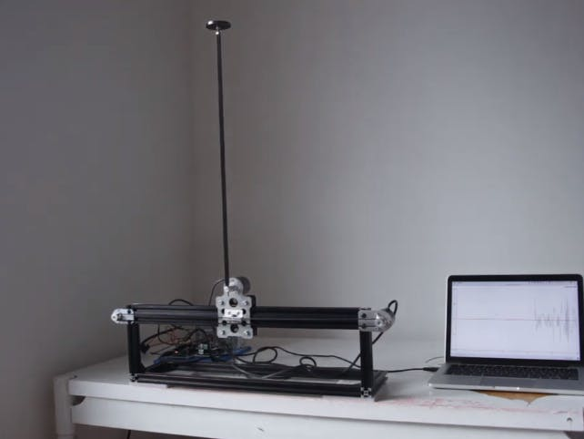

**free-body diagrams of the two elements of the inverted pendulum system.**



* the two Free Body Diagrams of the system. Summing the forces in the Free Body Diagram of the cart in the horizontal direction, we get the following equation of motion:

To get the second equation of motion, sum the forces

perpendicular to the pendulum

By substituting (2) equation into the (1) equation, we

get the equation of motion for this system

Note that the forces can be sum in the vertical direction,

but no useful information would be gained. Summing

the forces in the Free Body Diagram of the pendulum in

the horizontal direction, we can get an equation for N

These set of equations (3) & (6) should be linearized

about = ∅,Assume that theta = + ∅ (represents a small

angle from the vertical upward direction). Therefore,

cos 𝜃 = -1, sin 𝜃 = -1 and (d 𝜃 /dt) 2 = 0. After

linearization the two equations of motion become

(where u represents the input):

Combining equation (4) & (5), we get the second

dynamic equation:

To get rid of the P and N terms in the equation above,

sum the moments around the centroid of the pendulum

to get the following equation

**Transfer Function of Pendulum Model:**

From the transfer function above it can be seen that

there is both a pole and a zero at the origins. These can

be canceled and the transfer function becomes:

To obtain the transfer function of the linearized system

equations analytically, we must first take the Laplace

transform of the system equations (7) & (8). The

Laplace transforms are:

Since we will be looking at the angle, ∅ as the output of

interest, solve the equation (9) for X(s),

Substitute value of X(s) from equation (11) to (10) and

re-arrange. The transfer function is:

**Inverted pendulum design:**

**Cart:**

**Links :**

**PID Model:**

**Reference:**

1. [**https://ctms.engin.umich.edu/CTMS/index.php?example=InvertedPendulum&section=SystemModeling**](https://ctms.engin.umich.edu/CTMS/index.php?example=InvertedPendulum&section=SystemModeling)
2. [**https://www.youtube.com/watch?v=LcYd0goujWU&t=1888s**](https://www.youtube.com/watch?v=LcYd0goujWU&t=1888s)
3. [**https://www.youtube.com/watch?v=hAI8Ag3bzeE**](https://www.youtube.com/watch?v=hAI8Ag3bzeE)